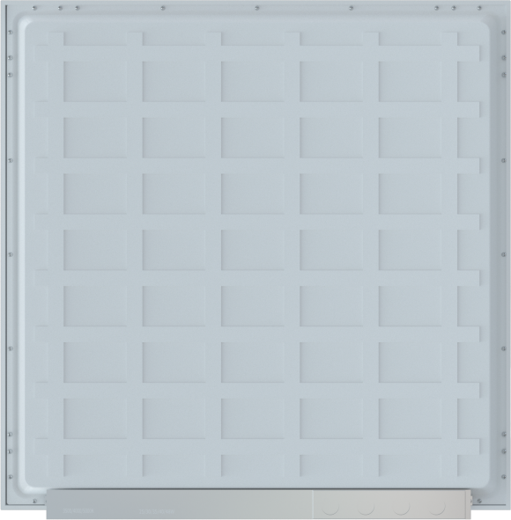



ProductProfile:
The PN01 Series Recessed Panel Light is a low-glare (UGR<19) LED luminaire featuring an iron frame with powder coating and a PS diffuser. Designed for offices, commercial spaces, and educational environments, It offers a slim 28mm profile with high efficiency up to 125 Lm/W. The recessed mounting design ensures seamless integration into standard ceiling grids.
Options：
> Smart Control:
0-10V Dimming and Triac Dimmer
> CCT: 5 CCT
> Installation:Surface mounting

Product Features：
> Up to 125 Lm/W
> Low glare UGR 19
> CCT & Wattage Adjustable
> IP40 / IK04
> Uniformity is greater than 0.9
> Intelligent energy conservation and environmental protection
> RAL9003 white finish
> 5 years warranty
Applications：
> Office lighting
> Campus lighting
> Commerical lighting
> Etc.



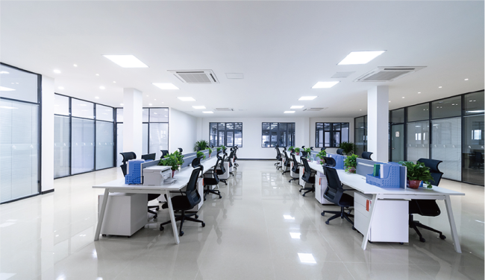

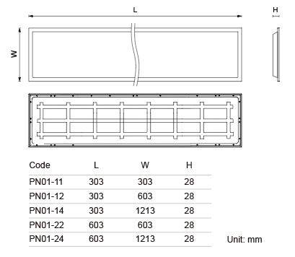
Dimension: Beam Angle:
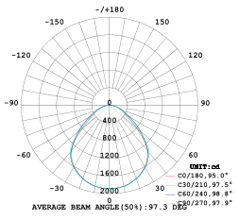

Technical Data:
Item | Symbol | 1X1 | 1X2 | 1X4 | 2X2 | 2X4
Product Code | / | PN01-11P15E  100-5CT | PN01-12P24E  125-5CT | PN01-14P35E  150-5CT | PN01-22P35E  150-5CT | PN01-24P60E  150-5CT
Size | mm | 303*303*28 | 303*603*28 | 303*1213*28 | 603*603*28 | 603*1213*28
Rated Power | W | 15W | 18-24W | 23-30-35W | 23-30-35W | 40-50-60W
Luminous Flux | LM | 1500LM | 3000LM | 5250LM | 5250LM | 9000LM
Lumen Efficacy | LM/W | 100LM/W | 125LM/W | 150LM/W | 150LM/W | 150LM/W
Color Index | Ra | Ra > 80
Color consistency | SDCM | SDCM < 5
Color Temperature | CCT/K | Single Color:2700K-3000K-3500-4000K-5000K (5CCT)
UGR | UGR | UGR < 19
Beam Angle | Degree | 95 Degrees
Input Voltage | V | 120V / 60HZ
Dimming | / | 0-10V Dimming and Triac Dimmer
Power Factor | PF | PF > 0.95
THD | THD | THD < 15%
Protection Level | IP/IK | IP40 / IK04
Fixture Material | / | 6063LA + PS
Fixture Finish | / | White RAL9003
Storage Temperature | ℃ | -40 ~ +80℃
Working Temperature | ℃ | -20 ~ +45℃
Net Weight | KG | 0.41 | 0.82 | 1.62 | 1.64 | 3.24
Gross Weight | KG | 4.6 | 9.2 | 14.16 | 14.32 | 14.46
Package Size | mm | 415*350*360/  10pcs | 640*415*360/  10pcs | 1235*340*340/  8pcs | 635*340*660/  8pcs | 1240*195*645/  4pcs
20GP | pcs | 5,040 | 2,520 | 1,600 | 1,250 | 570
40GP | pcs | 11,760 | 5,880 | 3,450 | 2,550 | 1,250

